**What is HTML**

**HTML** stands for**Hyper Text Markup Language**. It is used to design web pages using the **markup language**. HTML is the combination of **Hypertext** and **Markup language**. Hypertext defines the link between the web pages and markup language defines the text document within the tag that define the structure of web pages.

## What is HTML used for

HTML is used to create the structure of web pages that are displayed on the World Wide Web (www). It contains Tags and Attributes that are used to design the web pages. Also, we can link multiple pages using Hyperlinks

HTML is NOT case sensitive  
<p> = <P>  
<html> = <HTML>  
<head> = <HEAD>  
<body> = <BODY

The component used to design the structure of website are called html tags.

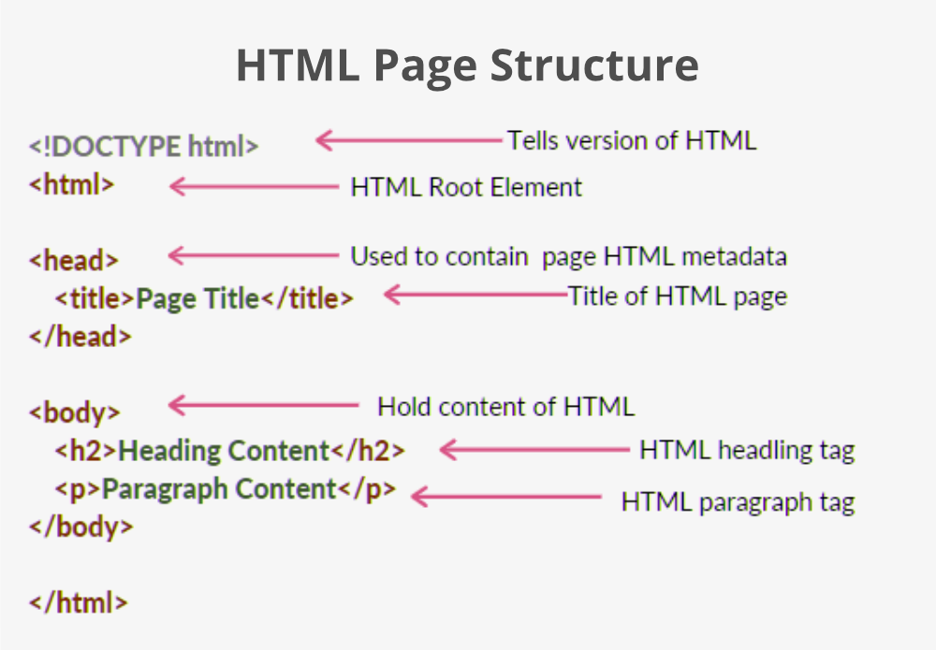

* **<!DOCTYPE HTML>**

The DOCTYPE HTML justifies the document type means this document in an html5 or any other document and helps browser to display web page correctly.

* **<html lang= “en”>**

Lang attribute inside the html tag define the language type of the html document

* **<head> and inside the head tag.**

The [head](https://developer.mozilla.org/en-US/docs/Glossary/Head) of an HTML document is the part that is not displayed in the web browser when the page is loaded. It contains information such as the page [<title>](https://developer.mozilla.org/en-US/docs/Web/HTML/Element/title), links to [CSS](https://developer.mozilla.org/en-US/docs/Glossary/CSS) (if you choose to style your HTML content with CSS), style tag , links to custom favicons ,and other metadata.

Head tag is used to store meta data, title and SEO.

SEO - Search engine optimization: the process of making your site better for search engines.meta tags are help seo improve .

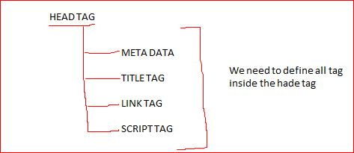

1. Mata tag-: it is used to describe the contents of a website. Meta means providing information about information. Therefore, meta tags are used to define the keywords and descriptions on our website.

*<!*DOCTYPE html*>*

*<*html lang="en"*>*

*<*head*>*

***<*meta charset="UTF-8"*>***

We know that various character coding are available like ASCCI , UTF- 8,UTF-16. UTF-8 is one the popular character coding method .majority website use this method. And UTF- 8 provide multi-lingual support.

*<*meta http-equiv="X-UA-Compatible" content="IE=edge"*>*

this line means when you rander your web-page you use latest render engineer.

*<*meta name="viewport" content="width=device-width, initial-scale=1.0"*>*

name="viewport" this line means wherever your content is display on browser that is your viewport content="width=device-width" this line means your viewport width change according to the device initial-scale=1.0" this line means you can fix your viewport width initially.

*<*meta name="description" content="Learn Full Stack Web Development: Master Course · Master Course on Dynamic Programming · Master Course on Graph Algorithms · Complete Android Development ..."*/>*

A meta description is an HTML element that provides a brief summary of a web page. means which type of contents are available in this web page

*<*meta http-equiv="refresh" content="30”>

Refresh document every 30 seconds:

*<*meta name="keywords" content="HTML, CSS, JavaScript"*>*

Define keywords for search engines: Keywords helps for better search.

*<*title*>*title of the web page*</*title*>*

this is title of the web page

*<*link rel="shortcut icon" href="./favicon.png" type="image/x-icon"*>*

Add favicon icon infron of title of the web page

*<*link rel="stylesheet" href="anurag.css" */>*

this is how you include external css file.

*<*script src="anurag.js"*></*script*>*

this is how you include external javascript file.

*</*head*>*

*<*body*>*

*</*body*>*

*</*html*>*

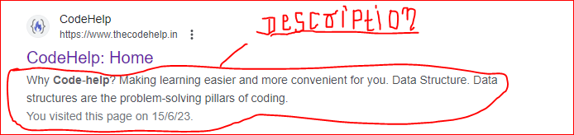

1. **Title tag-:**

* Title tag is use to provide the title of the website. The title should describe the content and the meaning of the page.
* The page title is very important for search engine optimization (SEO). The text is used by search engine algorithms to decide the order when listing pages in search results.
* The title is shown in the browser's title bar:



* Use the HTML <link> element to insert a favicon. Favicon is nothing but it is like a icons we use this icon for title of the web page.

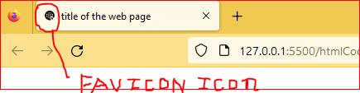

**The HTML character set Attribute.**

To display an HTML page correctly, a web browser must know the character set used in the page. This is specified in the <meta> tag:

* If not specified, UTF-8 is the default character set in HTML.
* UTF-8 covers almost all of the characters and symbols in the world
* Many UTF-8 characters cannot be typed on a keyboard, but they can always be displayed using numbers (called entity numbers)

<p>I will display A B C</p>  
<p>I will display &#65; &#66; &#67;</p>

* Emoji’s are also characters from the UTF-8 alphabet:

|  |  |  |  |
| --- | --- | --- | --- |
| **Emoji** | **Value** |  | |
| 🗼 | &#128508; |  | |
| 🗽 | &#128509; |  | |
| 🗿 | &#128511; |  | |
| 😀 | &#128512; |  | |
| 😁 | &#128513; |  | |
| 😂 | &#128514; |  | |
| 😃 | &#128515; | [»](https://www.w3schools.com/html/tryit.asp?filename=tryhtml_emoji_128516) |
| 😄 | &#128516; |  | |
|  |  |  | |
| 😅 | &#128517; |  | |

<p>&#128512;</p>

* **<body>**

The <body> element defines the document's body, and is a container for all the visible contents, such as headings, paragraphs, images, hyperlinks, tables, lists, etc.

## HTML Element

## An HTML element is defined by a start tag, some content, and an end tag

* The HTML element is everything from the start tag to the end tag
* Some HTML elements have no content (like the <br> element). These elements are called empty elements. Empty elements do not have an end tag!

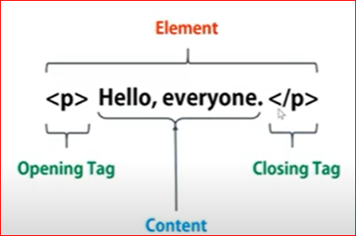

**Comments in HTML**

the comment is used to insert comments in the source code. Comment are not displayed in browser and it helps easy to understand the code.

<!-- Write your comments here --> ctr+/

**TAGS IN HTML**

Tag is a **Markup** entity or special words . it provides the structure , semantic and formatting of our content. . HTML tags contain three main parts: opening tag, content and closing tag. But some HTML tags are unclosed tags.

|  |  |  |
| --- | --- | --- |
| semantic | structure | formatting |
| <h1> to <h6> | <html> | <b> |
| <p> | <body> | <i> |
| <a> | <head> | <u> |
| <table>,<ul>,<ol>,<tr>, <td>  <th> | <header>,<footer> | <strong> |
| <img> | <main> | <em> |
| <form> | <aside> | <sub>, <sup> |
| <input> | <article>,<section> | <pre> |

**Some tags are self closing tag or no end tag**

**<br>**

**<img>**

**<hr>**

**TAGS IN HTML**

1. **Heading Tag**

* HTML headings are defined with the <h1> to <h6> tags. <h1> defines the most important heading. <h6> defines the least important heading.
* Search engines use the heading to index the structure and content of your web page.
* HTML headings use for titles or subtitles that you want to display on webpage not for makes text big or bold.

# Heading 1 (most important)

## Heading 2

Heading is used to display the titles or subtitles that you wants to display on web page.

### Heading 3

#### Heading 4

##### Heading 5

###### Heading 6 (**least important**)

1. **Horizontal rules<hr>**

The <hr> element is use to draw a horizontal line on web page.

1. **Line break tag<br>**

The <br> element define line break . if you want a line break or you want jump new line without starting new paragraph using <br> tag.

1. **Paragraph Tag**

A paragraph always starts on a new line, and browsers automatically add some white

space (a margin) before and after a paragraph. The HTML <p> element defines paragraph.  
 ex-: <p> This is a sample paragraph </p>

1. **<Pre> Tag.**

The html <pre> element define per- formatted text .The <pre> tag preserve both white space and line break. Other words Generally html ignore the white space but if you use <pre> tag it shows your content as it is

|  |  |
| --- | --- |
| **EXAMPLE OP <P> TAG**  <p>   My Bonnie lies over the ocean.    My Bonnie lies over the sea.    My Bonnie lies over the ocean.    Oh, bring back my Bonnie to me. </p>  OUTPUT  In HTML, spaces and new lines are ignored.  My Bonnie lies over the ocean. My Bonnie lies over the sea. My Bonnie lies over the ocean. Oh, bring back my Bonnie to me. | **EXAMPLE OP <PRE> TAG**  <pre>   My Bonnie lies over the ocean.    My Bonnie lies over the sea.    My Bonnie lies over the ocean.    Oh, bring back my Bonnie to me. </pre>  OUTPUT  The pre tag preserves both spaces and line breaks:  My Bonnie lies over the ocean.  My Bonnie lies over the sea.  My Bonnie lies over the ocean.  Oh, bring back my Bonnie to me. |

1. **HTML <a> Tag.**

The <a> tag defines a hyperlink, which is used to link from one page to another. The most important attribute of the <a> element is the href attribute, which indicates the link's destination.

Note

* A link does not have to be text. A link can be an image, button or any other HTML element!
* By default, links will appear as follows in all browsers:
* An unvisited link is underlined and blue
* A visited link is underlined and purple
* An active link is underlined and red.

*<*a href="https://www.google.com"*>* click here*</*a*>*

* <a>-:it is used to define the hyper link. hyper links

Means jump one page to another page.

* href attribute-:it indicates the link destination
* click here-: indicates the link title or information use as button.

1. **HTML image Tag.**

The HTML <img> tag is used to embed an image in a web page. Images are not technically inserted into a web page; images are linked to web pages. The <img> tag creates a holding space for the referenced image.

The <img> tag has two required attributes:

* src - Specifies the path to the image
* alt - Specifies an alternate text for the image. If a browser cannot find an image, it will display the value of the alt attribute:

syntax

<img src="*url*" alt="alternatetext">

**How to provide height and width of an image.**

**Two way**

* You can use the style attribute to specify the width and height of an image.

<img src="img_girl.jpg" alt="Girl in a jacket" style="width:500px;height:600px;">

* Alternatively, you can use the width and height attributes. The width and height attributes always define the width and height of the image in pixels

<img src="img_girl.jpg" alt="Girl in a jacket" width="500" height="600">

## Animated Images

HTML allows animated GIFs:

Example

<img src="programming.gif" alt="Computer Man" style="width:48px;height:48px;">

1. **SUB AND SUP TAG .**

* The <sup> tag defines superscript text. Superscript text appears half a character above the normal line, and is sometimes rendered in a smaller font. Superscript text can be used for footnotes, like WWW[1]
* The <sub> tag defines subscript text. Subscript text appears half a character below the normal line, and  is sometimes rendered in a smaller font. Subscript text can be used for chemical formulas, like H2O

example

*10<*sup*>*2*</*sup*>*

10 log *<*sub*>*2*</*sub*>*

*<*p*>*This text contains *<*sub*>*subscript*</*sub*>* text.*</*p*>*

*<*p*>*This text contains *<*sup*>*superscript*</*sup*>* text.*</*p*>*

1. **<br> tag -:use to break the line.**
2. **<u> tag -: use to under-line the text.**
3. **<b> tag -: use to make bold the text.**
4. **<i> tag -: use to make italic the text.**
5. **<em> tag -: use to emphasis or italic the text.**
6. **<small> tag -: use to make small font size.**

HTML Quotation and Citation Elements

1. <blockquote> elements: The HTML <blockquote> element defines a section that is quoted from another source. When quote is display on the browser it left some space both the side.

*<*blockquote cite="http://www.worldwildlife.org/who/index.html"*>*

For 60 years, WWF has worked to help people and nature thrive. As the world's leading conservation organization, WWF works in nearly 100 countries. At every level, we col

*</*blockquote*>*

**Cite attribute is use to define source of quote.**

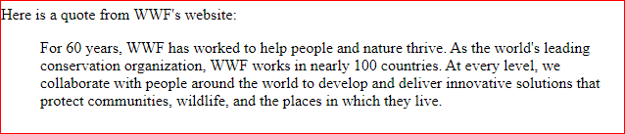

1. The HTML <q> tag defines a short quotation. Browsers normally insert quotation marks around the quotation.

*<*p*>*WWF's goal is to: *<*q*>*Build a future where people live in harmony with nature.*</*q*></*p*>*

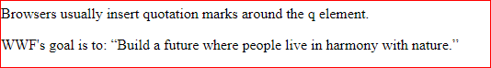

1. **HTML <abbr> :**The HTML <abbr> tag defines an abbreviation or an acronym, means <abbr> tag is used to mark the specific word with doted underline for understand the actual meaning of word. Like WHO,SP,WWW ETC.

**Tip:** Use the global title attribute to show the description for the abbreviation/acronym when you mouse over the element.

**EXAMPLE**

*<*p*>*The *<*abbr title="World Health Organization"*>*WHO*</*abbr*>* was founded in 1948.*</*p*>*

Output like this



1. **HTML <bdo>(Bi-Directional Override):** The HTML <bdo> tag is used to change the current text direction

Example

*<*bdo dir="rtl"*>*This line will be written from right to left*</*bdo*>*

Left--🡪tfel

1. **Block-level Elements**

A block-level element always starts on a new line, and the browsers automatically add some space (a margin) before and after the element. And A block-level element always takes up the full width available.

**Example**

*<*p style="border: 2px solid black"*>*Hello World*</*p*>*

*<*div style="border: 2px solid black"*>*Hello World*</*div*>*

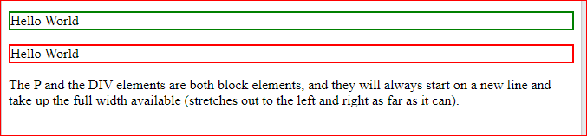

**Here are the block-level elements in HTML:**

[**<address>**](https://www.w3schools.com/tags/tag_address.asp)[**<article>**](https://www.w3schools.com/tags/tag_article.asp)[**<aside>**](https://www.w3schools.com/tags/tag_aside.asp)[**<blockquote>**](https://www.w3schools.com/tags/tag_blockquote.asp)[**<canvas>**](https://www.w3schools.com/tags/tag_canvas.asp)[**<dd>**](https://www.w3schools.com/tags/tag_dd.asp)[**<div>**](https://www.w3schools.com/tags/tag_div.asp)[**<dl>**](https://www.w3schools.com/tags/tag_dl.asp)[**<dt>**](https://www.w3schools.com/tags/tag_dt.asp)[**<fieldset>**](https://www.w3schools.com/tags/tag_fieldset.asp)[**<figcaption>**](https://www.w3schools.com/tags/tag_figcaption.asp)[**<figure>**](https://www.w3schools.com/tags/tag_figure.asp)[**<footer>**](https://www.w3schools.com/tags/tag_footer.asp)[**<form>**](https://www.w3schools.com/tags/tag_form.asp)[**<h1> <h6>**](https://www.w3schools.com/tags/tag_hn.asp)[**<header>**](https://www.w3schools.com/tags/tag_header.asp)[**<hr>**](https://www.w3schools.com/tags/tag_hr.asp)[**<li>**](https://www.w3schools.com/tags/tag_li.asp)[**<main>**](https://www.w3schools.com/tags/tag_main.asp)[**<nav>**](https://www.w3schools.com/tags/tag_nav.asp)[**<noscript>**](https://www.w3schools.com/tags/tag_noscript.asp)[**<ol>**](https://www.w3schools.com/tags/tag_ol.asp)[**<p>**](https://www.w3schools.com/tags/tag_p.asp)[**<pre>**](https://www.w3schools.com/tags/tag_pre.asp)[**<section>**](https://www.w3schools.com/tags/tag_section.asp)[**<table>**](https://www.w3schools.com/tags/tag_table.asp)[**<tfoot>**](https://www.w3schools.com/tags/tag_tfoot.asp)[**<ul>**](https://www.w3schools.com/tags/tag_ul.asp)[**<video>**](https://www.w3schools.com/tags/tag_video.asp)

1. **Inline Elements:-**

An inline element does not start on a new line. And only takes up as much width as necessary.

**Example**

*<*span style="border: 2px solid red"*>*This is an inline span*</*span*>* *<*span style="border: 2px solid black"*>*Hello World*</*span*>* *<*span style="border: 2px solid green"*>* element inside a paragraph.*</*span*>*

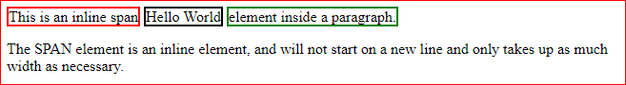

Here are the inline elements in HTML:

[**<a>**](https://www.w3schools.com/tags/tag_a.asp)[**<abbr>**](https://www.w3schools.com/tags/tag_abbr.asp)[**<acronym>**](https://www.w3schools.com/tags/tag_acronym.asp)[**<b>**](https://www.w3schools.com/tags/tag_b.asp)[**<bdo>**](https://www.w3schools.com/tags/tag_bdo.asp)[**<big>**](https://www.w3schools.com/tags/tag_big.asp)[**<br>**](https://www.w3schools.com/tags/tag_br.asp)[**<button>**](https://www.w3schools.com/tags/tag_button.asp)[**<cite>**](https://www.w3schools.com/tags/tag_cite.asp)[**<code>**](https://www.w3schools.com/tags/tag_code.asp)[**<dfn>**](https://www.w3schools.com/tags/tag_dfn.asp)[**<em>**](https://www.w3schools.com/tags/tag_em.asp)[**<i>**](https://www.w3schools.com/tags/tag_i.asp)[**<img>**](https://www.w3schools.com/tags/tag_img.asp)[**<input>**](https://www.w3schools.com/tags/tag_input.asp)[**<kbd>**](https://www.w3schools.com/tags/tag_kbd.asp)[**<label>**](https://www.w3schools.com/tags/tag_label.asp)[**<map>**](https://www.w3schools.com/tags/tag_map.asp)[**<object>**](https://www.w3schools.com/tags/tag_object.asp)[**<output>**](https://www.w3schools.com/tags/tag_output.asp)[**<q>**](https://www.w3schools.com/tags/tag_q.asp)[**<samp>**](https://www.w3schools.com/tags/tag_samp.asp)[**<script>**](https://www.w3schools.com/tags/tag_script.asp)[**<select>**](https://www.w3schools.com/tags/tag_select.asp)[**<small>**](https://www.w3schools.com/tags/tag_small.asp)[**<span>**](https://www.w3schools.com/tags/tag_span.asp)[**<strong>**](https://www.w3schools.com/tags/tag_strong.asp)[**<sub>**](https://www.w3schools.com/tags/tag_sub.asp)[**<sup>**](https://www.w3schools.com/tags/tag_sup.asp)[**<textarea>**](https://www.w3schools.com/tags/tag_textarea.asp)[**<time>**](https://www.w3schools.com/tags/tag_time.asp)[**<tt>**](https://www.w3schools.com/tags/tag_tt.asp)[**<var>**](https://www.w3schools.com/tags/tag_var.asp)

Note: An inline element cannot contain a block-level element!

**21.The <span> Element:**

The <span> element is an inline container it is used to text formatting . whenever you use this tag your text remains in the same line instead of going to the second line.

It has no local attributes for formatting , it use the global attributes for formatting . example class, id and style

**22.The <div> Element:**

The <div> element is often used as a container for other HTML elements. It is block level containr.

**Example**

*<!*DOCTYPE html*>*

*<*html lang="en"*>*

*<*head*>*

*<*meta charset="UTF-8"*>*

*<*meta name="viewport" content="width=device-width, initial-scale=1.0"*>*

*<*title*>*Document*</*title*>*

*</*head*>*

*<*body*>*

div tag is a block-level element and it always starts on a new line and it contains the full width available . *<*br*><*br*>*

*<*div style="border:2px solid green"*>*Lorem ipsum dolor sit, amet cons*</*div*>* *<*br*>*

*<*div style="border:2px solid red "*>*Lorem ipsum dolor sit, amet.*</*div*><*br*><*br*><*br*>*

span tag is a inline element and it does not start on a new line. And it contain the width according to requirements. *<*br*>* *<*br*>*

*<*span style="border:2px solid green"*>*Lorem ipsum dolor sit, amet consectet*</*span*>*

*<*span style="border:2px solid red"*>*Lorem ipsum dolor sit, amet consectetur.*</*span*>*

*</*body*>*

*</*html*>*

**22.The <iframe> tag**

An HTML iframe is used to display a web page within a web page. Means iframe tag is used create a frame.

*<!*DOCTYPE html*>*

*<*html lang="en"*>*

*<*head*>*

*<*meta charset="UTF-8"*>*

*<*meta name="viewport" content="width=device-width, initial-scale=1.0"*>*

*<*title*>*Document*</*title*>*

*</*head*>*

*<*body*>*

*<*h2*>*An HTML iframe is used to display a web page within a web page. *</*h2*>*

*<*iframe src="Tags.html" style="width:70%; height: 70%;" frameborder="2" title="its a frame" *></*iframe*>*

    use some attribute for iframe.

* src attribute : The src attribute is use to defines the URL of the page which is embeded in this frame.

* style attribute : the style attribute is used to provide the height and width of the frame or many more

* title attribute : title attribute is use to provide the title of frame as a toolip.

    *frameborder attribute: it is use to provide a bordr.

*</*body*>*

*</*html*>*

**ATTRIBUTES IN HTML**

HTML attributes is used to provide some additional properties for html element.

* All HTML elements can have **attributes**
* Attributes provide **additional information** about elements
* Attributes are always specified in **the start tag**
* Attributes usually come in name/value pairs like: **name="val”**

Syntax:-

<tag name attributes name = “attributes value”>

Example:-

*<*p align="center"*>*hello anurag*</*p*>*

* Some element have required specific attribute.

*<*img src="location.jpeg"*>*

*<*input type="text"*>*

* Some attributes have no value.

*<*input type="text" required*>*

*<*input type="text"disabled*>*

Required

This type of attributes have no value so this type of attributes is called Boolean attributes

Disabled

**HTML Links - The target Attribute**

By default, the linked page will be displayed in the current browser window. To change this, you must specify another target for the link.

The target attribute specifies where to open the linked document.

The target attribute can have one of the following values:

* _self - Default. Opens the document in the same window/tab as it was clicked
* _blank - Opens the document in a new window or tab
* _parent - Opens the document in the parent frame
* _top - Opens the document in the full body of the window

**URL(UNIFORM SOURCE LOCATOR)**

IT complete address of any websites or particular image or web site.

## Absolute URLs vs. Relative URLs

## HTML Links - Use an Image as a Link

To use an image as a link, just put the <img> tag inside the <a> tag:

*<*a href="https://www.google.com"*><*img src="download.jpeg" alt="google image" style="width:42px; title=”open google”"*></*a*>*

* alt attribute-: it is used to provide alternate text for an image .if the user cant view image for some reason
* title attributes -: the title attributes specifies extra information about an button. The information is most often shown as a tooltip text when the mouse moves over the element. Title attributes is use with image tag or anchor tag.
* The style Attribute:- The style attribute is used to add styles to an element, such as color, font, size, and more.

Windows screen

ELEMENT

**VISIT GOOGLE**

TOOLTIP

OPEN GOOGLE GOOGLE

**ID ATTRIBUTES**

The HTML id attribute is used to specify a unique id for an HTML element. You cannot have more than one element with the same id in an HTML document.

If you use id attribute we can target particular element at a time to provide some style.

Ex-:

Suppose we create a blog page in this blog page 3 to 4 paragraph are mention if we want to provide some style for any particular paragraph at a time we can do with the help of id.

**blog page**

Suppose we want provide some style of any individual paragraph we can directly target with the help of id attribute.5

BLOG

Paragraph 1:

Paragraph 2:

Paragraph3:

Paragraph 4:

**CLASS ATTRIBUTES :**

The HTML class attribute is used to specify a class for an HTML element. You can have more than one element with the same class in an HTML document.

If you use class attribute we can target multiple element at a time to provide some style.

Ex-:

Suppose we create a blog page in this blog page 3 to 4 paragraph are mention if we want to provide some same style for multiple paragraph at a time we can do with the help of class.

We can also do with the help of id attributes but we need to provide different id for each paragraph.

**blog page**

Suppose we want provide some style of paragraph 2 and 3 we directly target para 2 and 3 with the help of class attribute.

BLOG

Paragraph 1:

Paragraph 2:

Paragraph3:

Paragraph 4:

**Some of the Attributes are.**

1. href Attribute

The <a> tag defines a hyperlink. The href attribute specifies the URL of the page the link goes to

<a href="https://www.w3schools.com">Visit W3Schools</a>

1. src Attribute

The <img> tag is used to embed an image in an HTML page. The src attribute specifies the path to the image to be displayed:

<img src="img_girl.jpg">

The <img> tag should also contain the width and height attributes, which specify the width and height of the image (in pixels):

<img src="img_girl.jpg" width="500" height="600">

1. **alt attribute**

The required alt attribute for the <img> tag specifies an alternate text for an image, if the image for some reason cannot be displayed. This can be due to a slow connection, or an error in the src attribute, or if the user uses a screen reader.

<img src="img_girl.jpg" alt="Girl with a jacket">

1. **The style Attribute**

The style attribute is used to add styles to an element, such as color, font, size, and more.

<p style="color:red;">This is a red paragraph.</p>

## The title Attribute

The title attribute defines some extra information about an element.

The value of the title attribute will be displayed as a tooltip when you mouse over the element: we can use image tag and link tag.

<p title="I'm a tooltip">This is a paragraph.</p>

<https://www.youtube.com/watch?v=l1EssrLxt7E&list=PLfqMhTWNBTe3H6c9OGXb5_6wcc1Mca52n>

**Entities in html**

Some character are reversed in html . html character entities are used to display reserved character in html.

**We can display**

* Reserved character.

Use html entities to display these things

* Special character.
* Emoji’s
* Symbols

Syntax

&entity_name;

or

&#*entity_number : <*p*>*&#128507; *</*p*>*

|  |  |  |  |  |
| --- | --- | --- | --- | --- |
| **Result** | **Description** | **Entity Name** | **Entity Number** |  |
|  | non-breaking space  If you write 10 spaces in your text, the browser will  remove 9 of them. To add real spaces to your text, | &nbsp; | &#160; |  |
| < | less than | &lt; | &#60; |  |
| > | greater than | &gt; | &#62; |  |
| & | ampersand | &amp; | &#38; |  |
| " | double quotation mark | &quot; | &#34; |  |
| ' | single quotation mark (apostrophe) | &apos; | &#39; |  |
| ¢ | cent | &cent; | &#162; |  |
| £ | pound | &pound; | &#163; |  |
| ¥ | yen | &yen; | &#165; |  |
| € | euro | &euro; | &#8364; | [Try it »](https://www.w3schools.com/html/tryit.asp?filename=tryhtml_ent_euro) |
| © | copyright | &copy; | &#169; | [Try it »](https://www.w3schools.com/html/tryit.asp?filename=tryhtml_ent_copy) |
| ® | registered trademark | &reg; | &#174; |  |